Unloveable Shell, the Goddess of Oil

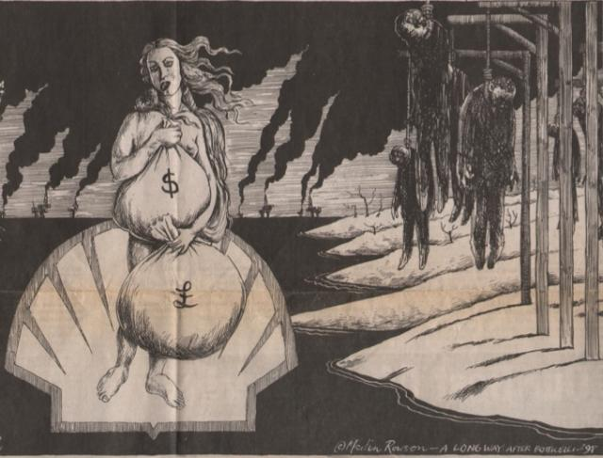

Shell kills and pollutes to get the loot

